## **Objectives**

* Explain about conditional rendering in React
* Define element variables
* Explain how to prevent components from rendering

In this hands-on lab, you will learn how to:

* Implement conditional rendering in React applications

## **Prerequisites**

The following is required to complete this hands-on lab:

* Node.js
* NPM
* Visual Studio Code

## **Notes**

Estimated time to complete this lab: **60 minutes.**

Create a React Application named “ticketbookingapp” where the guest user can browse the page where the flight details are displayed whereas the logged in user only can book tickets.

The Login and Logout buttons should accordingly display different pages. Once the user is logged in the User page should be displayed. When the user clicks on Logout, the Guest page should be displayed.

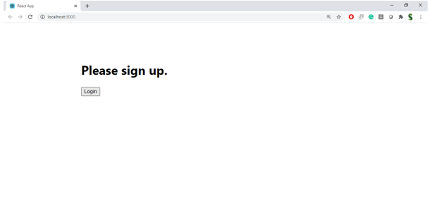

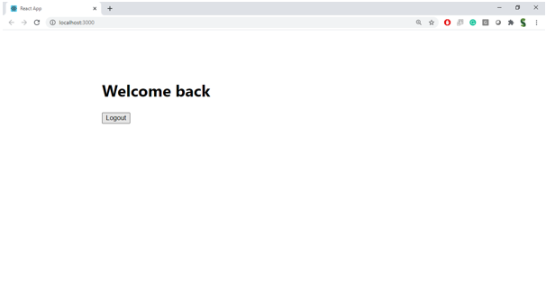

**Hint:**

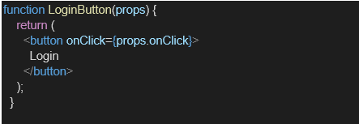

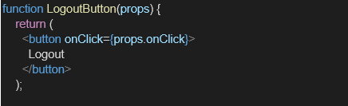

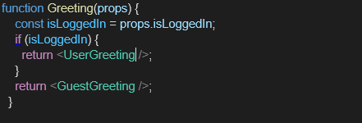

**App.js:**

import React, { useState } from 'react';

import LoginButton from './LoginButton';

import LogoutButton from './LogoutButton';

import GuestPage from './GuestPage';

import UserPage from './userPage';

import FlightDetails from './FlightDetails';

function App() {

  const [isLoggedIn, setIsLoggedIn] = useState(false);

  const handleLogin = () => setIsLoggedIn(true);

  const handleLogout = () => setIsLoggedIn(false);

  return (

    <div>

      <h1>Ticket Booking App</h1>

      {isLoggedIn ? (

        <>

          <LogoutButton onClick={handleLogout} />

          <UserPage />

        </>

      ) : (

        <>

          <LoginButton onClick={handleLogin} />

          <GuestPage />

        </>

      )}

      {/* Flight details are visible to everyone */}

      <FlightDetails />

    </div>

  );

}

export default App;

**FlightDetails.js :**

import React from 'react';

function FlightDetails() {

  return (

    <div>

      <h3>Flight Details</h3>

      <ul>

        <li>Flight 1 - Chennai to Delhi - 10:00 AM</li>

        <li>Flight 2 - Bangalore to Mumbai - 3:00 PM</li>

        <li>Flight 3 - Hyderabad to Kolkata - 6:00 PM</li>

      </ul>

    </div>

  );

}

export default FlightDetails;

**LoginButton.js:**

import React from 'react';

function LoginButton(props) {

  return (

    <button onClick={props.onClick}>

      Login

    </button>

  );

}

export default LoginButton;

**LogoutButton.js:**

import React from 'react';

function LogoutButton(props) {

  return (

    <button onClick={props.onClick}>

      Logout

    </button>

  );

}

export default LogoutButton;

**UserPage**.**js**:

import React from 'react';

function UserPage() {

  return <h2>Welcome User! You can now book your flight tickets.</h2>;

}

export default UserPage;

**GuestPage.js:**

import React from 'react';

function GuestPage() {

  return <h2>Welcome Guest! Please login to book tickets.</h2>;

}

export default GuestPage;